

**OPTIMIZING USER, GROUP, AND ROLE MANAGEMENT WITH ACCESS CONTROL AND WORKFLOWS**

**Team ID:** NM2025TMID19088

**Team Leader:** Divya J

**Team Size: 4**

**Team Member 1:** Fraicy T

**Team Member 2:** Gopikanithi R

**Team Member 3:** Harini B

**Problem Statement:** **Optimizing User, Group, and Role Management with Access Control and Workflows**

**Objective:**

**TASK INITIATION & MILESTONES**

**Milestone 1: User Management**

**Activity: Create Users**

* Login to ServiceNow.
*  Navigate: All → Search “Users” → Users (under System Security).
*  Click New and fill user details, then Submit.
* 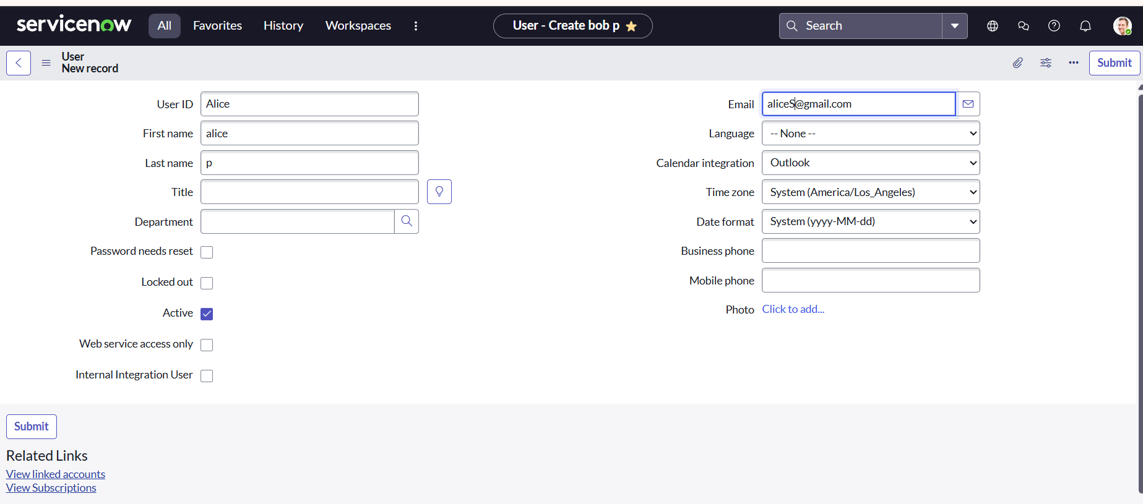 Repeat to add another user.

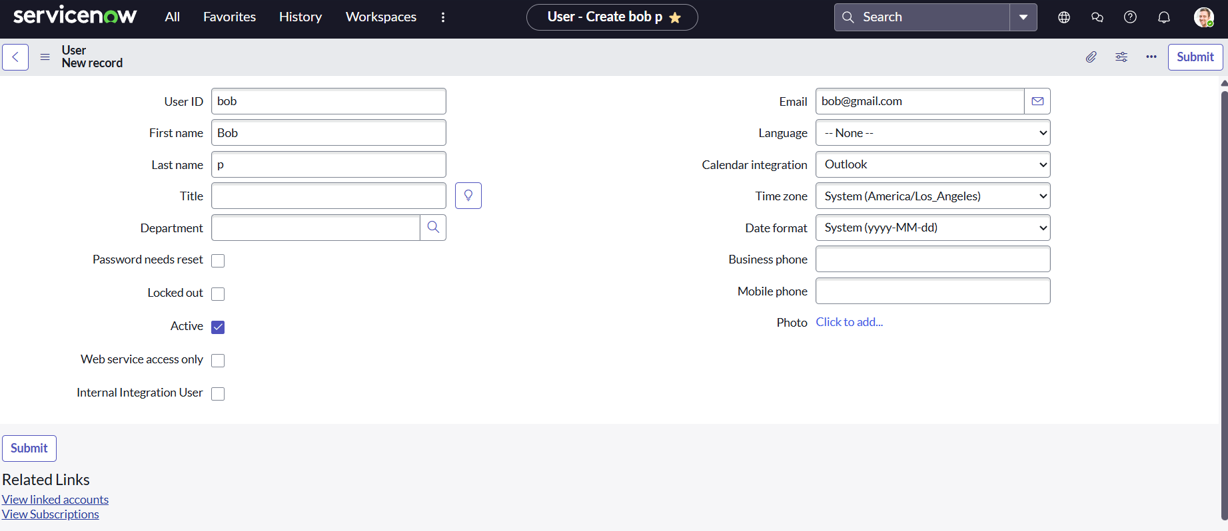

**Milestone 2: Group Management**

**Activity: Create Groups**

* All → Search “Groups” → Groups (under System Security).
* Click New, enter group details, then Submit.

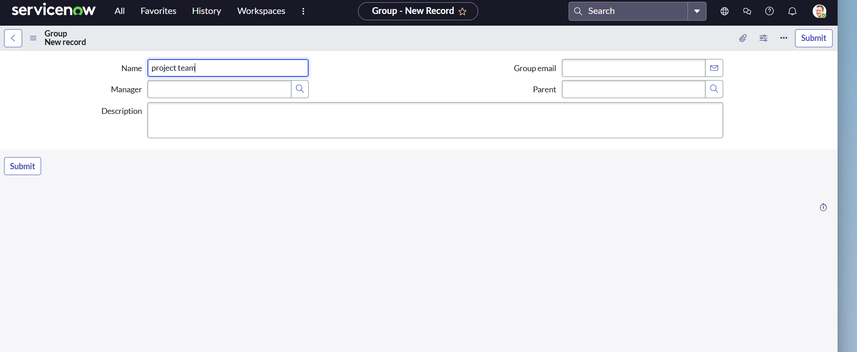

**Milestone 3: Role Management**

**Activity: Create Roles**

* All → Search “Roles” → Roles (under System Security).
* Click New, fill role details, then Submit.
* Repeat for an additional role.

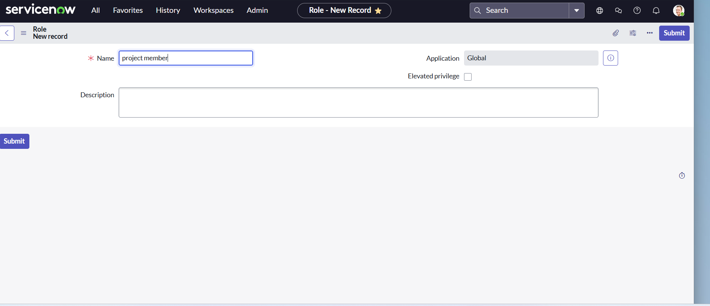

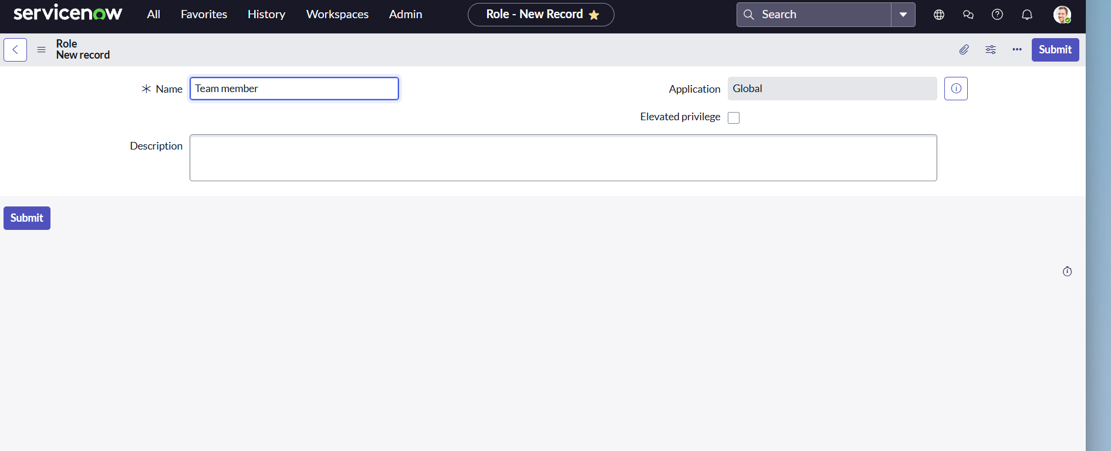

**Milestone 4: Table Management**

**Activity: Create Tables**

* All → Search “Tables” → Tables (under System Definition).
* Click New, name: “project table”, enable Create Module & Mobile Module.
* Add columns, set the new menu name.
* Submit.

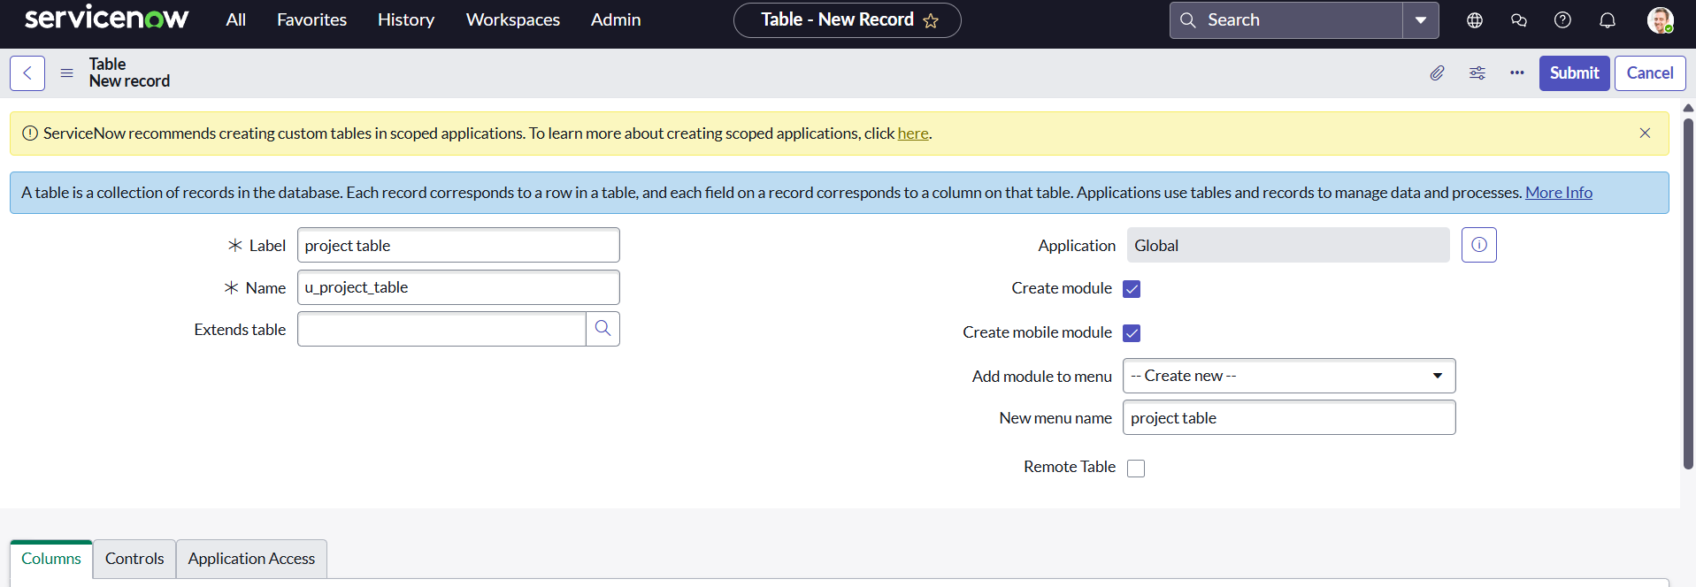

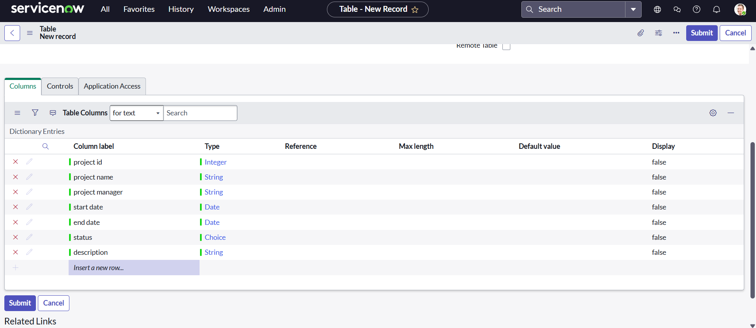

* Repeat for “task table 2”.

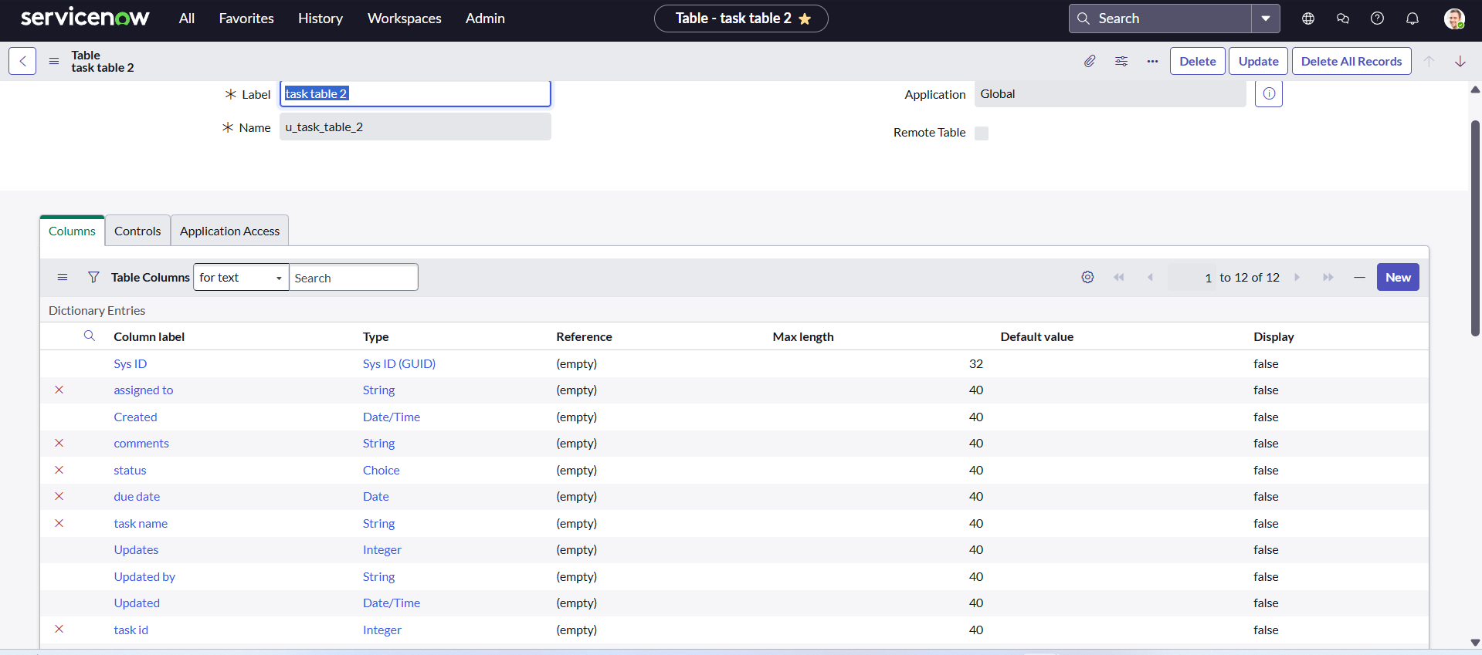

**Milestone 5: Assign Users to Groups**

* All → Search “Groups” → Project Team Group.
* Edit Group Members: add “alice p” and “bob p”, then Save.

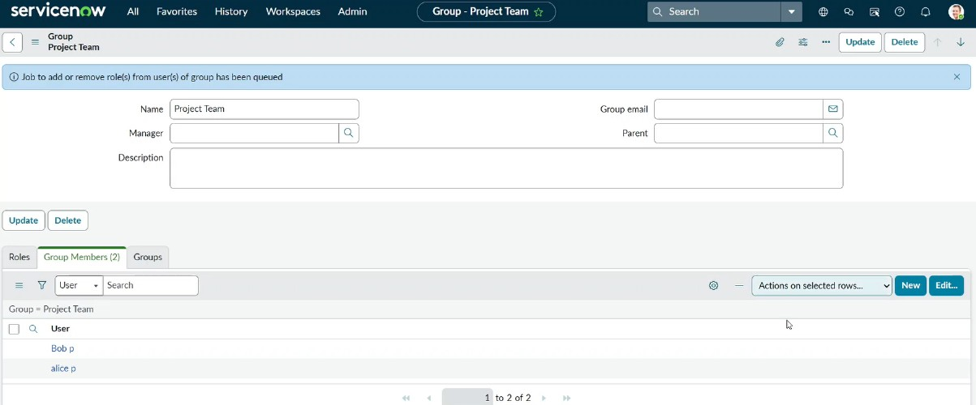

**Milestone 6: Assign Roles to Users**

Assign to Alice:

* All → Search users → Project Manager.
* Edit: set “project member”, add “u_project_table”, “u_task_table” roles, then save.

Assign to Bob:

* All → Search users → bob p.
* Edit: set “team member”, grant table role, Save.
* Impersonate bob p to verify task table 2 access.



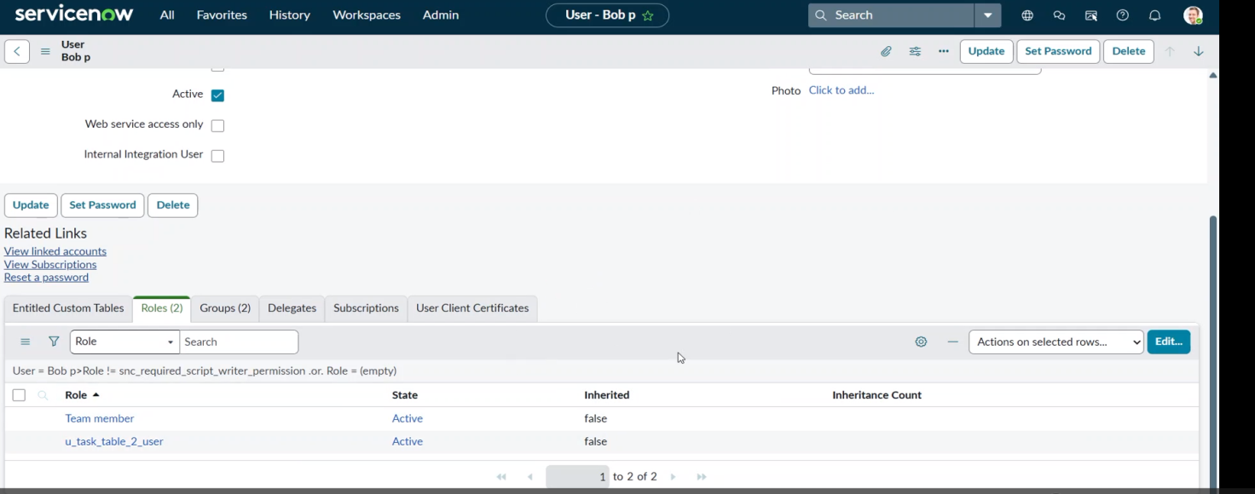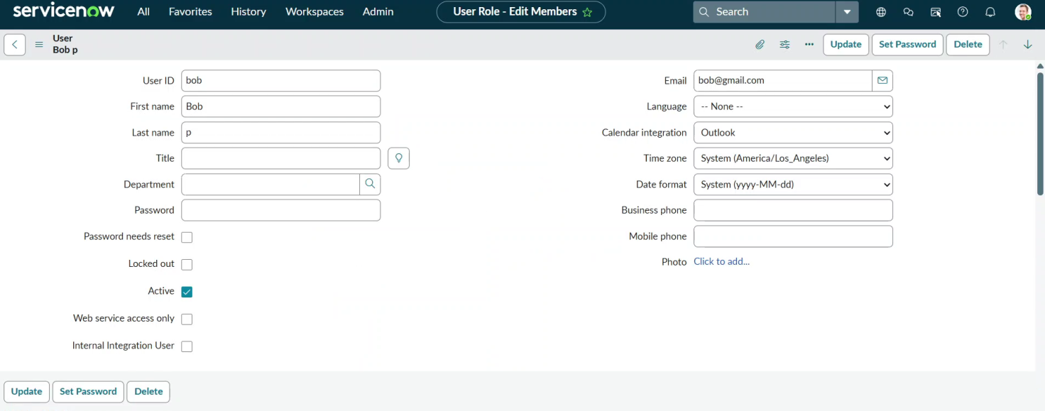

**Milestone 7: Table/Application Access**

1. When tables are created, applications/modules are auto-generated.
2. Edit “project table” and “task table 2” applications.
3. Assign correct roles ("project member", "team member") to each.

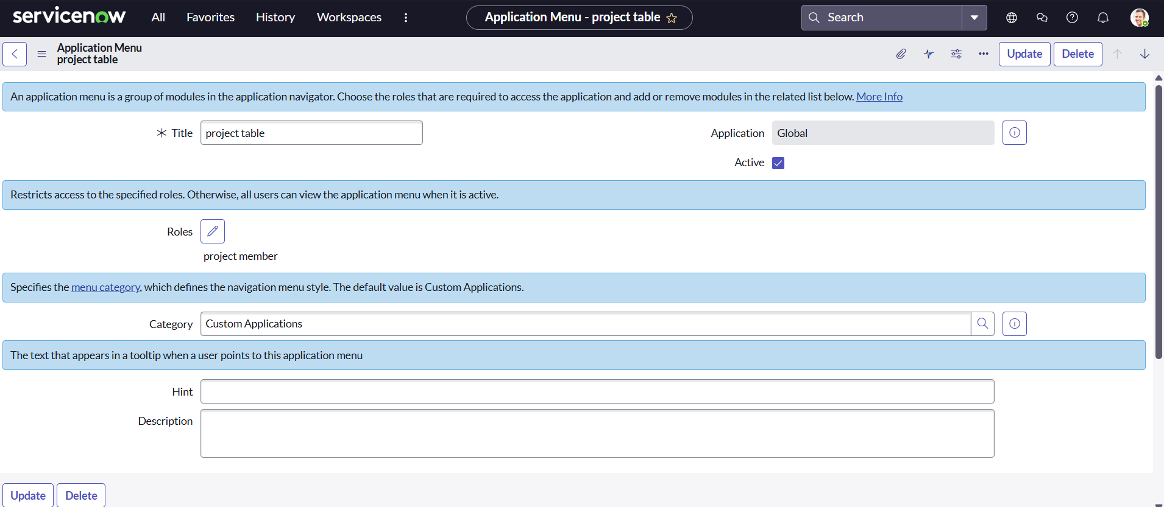

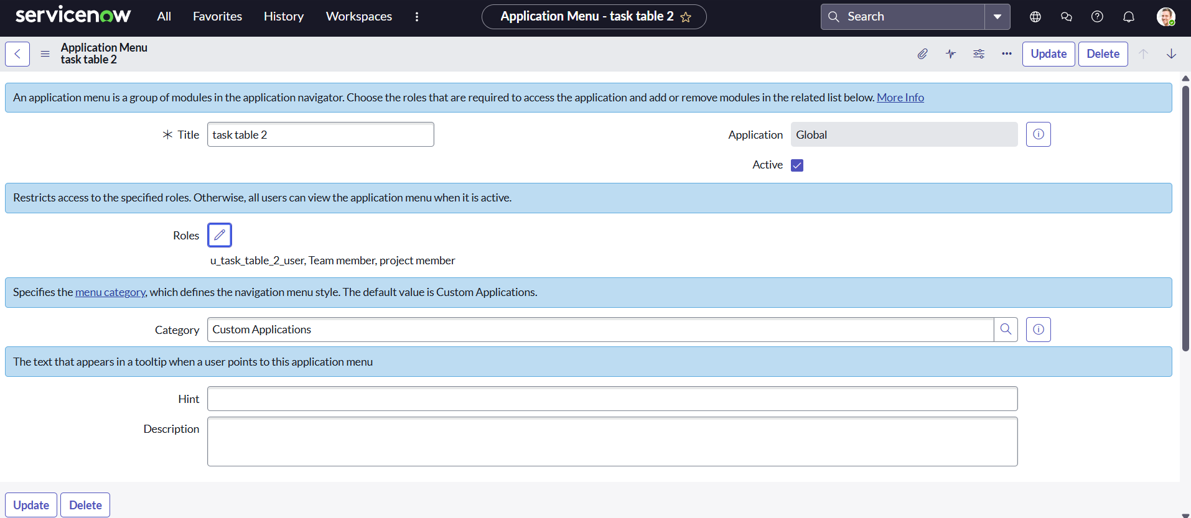

**Milestone 8: Access Control List (ACL)**

**Activity: Create ACLs**

* All → Search “ACL” → Access Control (System Security).
* Elevate role, click New, fill details for “task table” and “team member”.
* Submit, repeat for all necessary fields.
* Impersonate bob p; confirm edit access for “Comment” and “Status”.

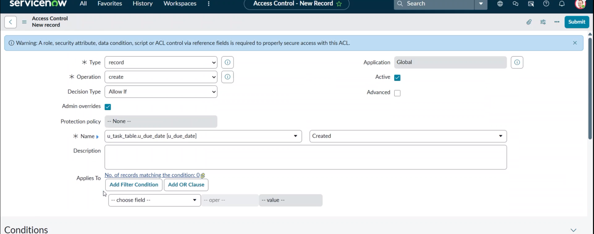

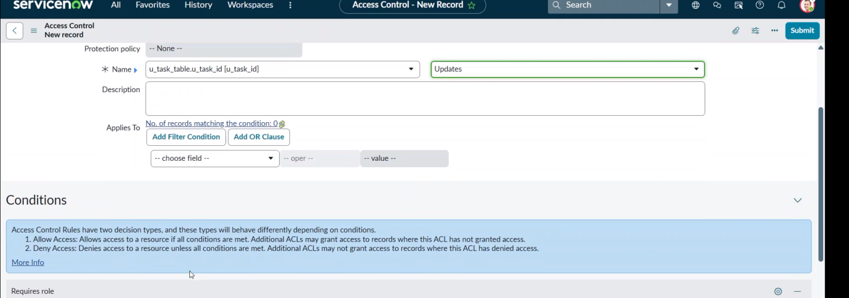

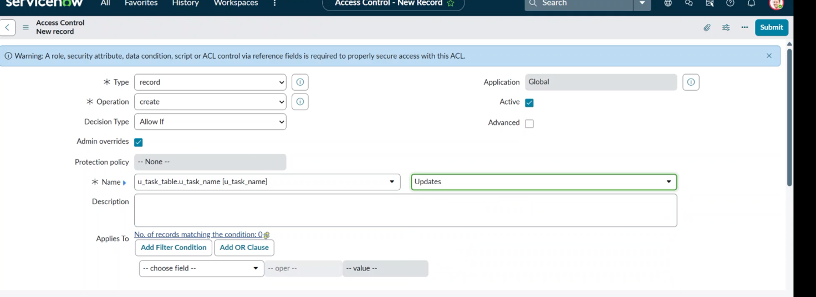

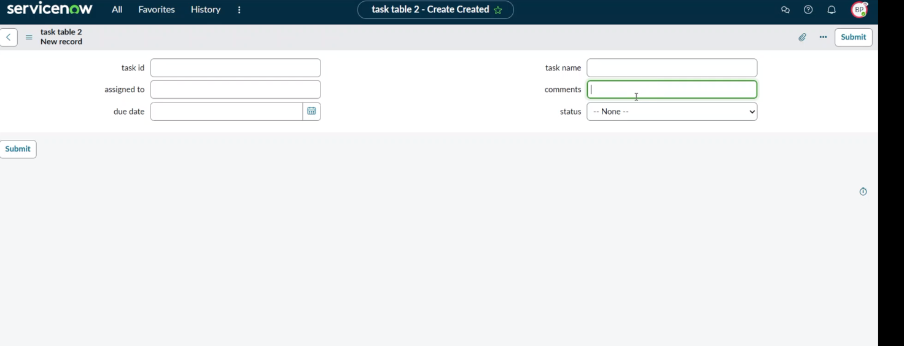**Milestone 9: Automation Flow**

**Activity: Flow for Assignment**

* All → Search “Flow Designer” → New Flow, name “task table”, Application: Global.

1. **Add Trigger:** On “create record” for “task table” with specified conditions.
2. **Add Action:** “Update records” → set “status” to “completed”.
3. **Add Approval Action:** Set “status” for approval, assign “alice p” as approver.
4. Test updating “task table” and approval process.

